Will Kelsey, Nick Krysko

Assignment 4 Use Case Model

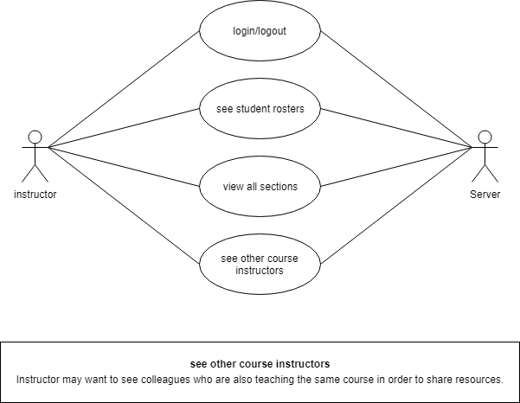 Instructors get the least abilities. It is not important for them to be involved with student registration. Therefore, they are able to view the courses they are teaching, view other courses that colleagues are teaching, and see the students they are teaching. Long term goals could include the ability for instructors to influence scheduling based on preference and student availabilities. Certain instructors could teach courses simultaneously so that students can select their preferred instructor, or ensure no class is taught at the same time, allowing huge flexibility in student schedules.